

TRIBHUVAN UNIVERSITY

INSTITUTE OF ENGINEERING PULCHOWK CAMPUS

REPORT ON STATIC ANALYSIS OF BIKE CHASSIS.

## TITLE PAGE

Prepared By:

**Sandip Poudel** (075Bme039)

DEPARTMENT OF MECHANICAL AND AEROSPACE ENGINEERING LALITPUR, NEPAL

AUGUST, 2022

## TABLE OF CONTENTS

TITLE PAGE 1

TABLE OF CONTENTS 2

LIST OF FIGURES 3

LIST OF TABLES 4

ABSTRACT 5

1. INTRODUCTION 5

2. CAD MODEL: 6

3. STRUCTURAL ANALYSIS OF BIKE CHASSIS: 7

3.1. LOADING CONDITIONS 7

3.2. Static Structural 8

4. Results 10

4.1. Mesh 11

4.2. Total Deformation 13

4.3. Maximum Principal Stress 14

4.4. Maximum Shear Stress 15

4.5. Equivalent Stress 16

4.6. Strain Energy 17

4.7. Equivalent Elastic Strain 18

4.8. Safety Factor 19

4.9. Harmonic Response 21

5. Material Data 22

6. CONCLUSION: 25

## LIST OF FIGURES

Figure 1 Cad Model 6

Figure 2 Loading Conditions 7

Figure 3Force 9

Figure 4Remote Force 9

Figure 5Remote Force 2 9

Figure 6Mesh 11

Figure 7Total Deformation 13

Figure 8Maximum Principal Stress 14

Figure 9Maximum Shear Stress 15

Figure 10Equivalent Stress 16

Figure 11Strain 17

Figure 12Equivalent Elastic Strain 18

Figure 13Safety Factor 19

Figure 14 Harmonic Response Solution 21

## LIST OF TABLES

Table 1Loads 8

Table 2Geometry 10

Table 3Geometry 12

Table 4Total Deformation 13

Table 5Maximum Principal Stress 14

Table 6Maximum Shear Stress 15

Table 7Equivalent Stress 16

Table 8Strain Energy 17

Table 9Equivalent Elastic Strain 18

Table 10Safety Factor 19

Table 11 Safety Tools 20

Table 12 Stress Tool 20

Table 13Harmonic Response on Loads at seat 21

Table 14Harmonic Response Solution Results 22

Table 15 Structural Steel Constants 22

Table 16Structural Steel Color 23

Table 17Structural Steel Compressive Ultimate Strength 23

Table 18Structural Steel Compressive Yield Strength 23

Table 19Structural Steel Tensile Yield Strength 23

Table 20Structural Steel Tensile Ultimate Strength 23

Table 21 Structural Steel Isotropic Secant Coefficient of Thermal Expansion 23

Table 22Structural Steel S-N Curve 24

Table 23Structural Steel Strain-Life Parameters 24

Table 24Structural Steel Isotropic Elasticity 24

Table 25Structural Steel Isotropic Relative Permeability 25

## ABSTRACT

The chassis frame forms the backbone of a vehicle, its principle function is to safely carry the maximum load for all designed operating conditions. Automotive chassis is the main carriage system of a vehicle. The chassis serves as a skeleton upon which parts like gearbox and engine are mounted. The two-wheeler chassis consists of a frame, suspension, wheels and brakes. The chassis is what truly sets the overall style of the two wheeler. Commonly used material for two-wheeler chassis is steel which is heavy in weight or more accurately in density. There are various alternate materials like aluminum alloys, titanium, carbon fiber, magnesium, etc. which are lesser in weight and provide high strength and thus can be used for chassis. This report deals with the design of two-wheeler chassis frame. The static loading was carried out on the chassis and the design is improving the mechanical behavior of the chassis The modeling work was carried out by the CATIA V5 and analysis was done by ANSYS software. The modeling would consider the geometry characteristics and analysis would consider the geometry import, meshing, loading condition, result evaluation. Where geometry import IGS file format was followed.

## INTRODUCTION

Whenever to build a motorcycle, the frame determines the basic look of the bike. Of course motorcycle frames affect not only the appearance of the bike but the handling and safety of the finished machine. Frames are the basic skeleton to which other components are attached. They hold the motorcycle tanks and engine and provide support to the whole bike. Motorcycle frames are usually made from welded aluminium, steel or alloy, carbon-fiber is used in some expensive or custom frames. The purpose of a motorcycles frame is to act as a base on which all the various components can be bolted. The engine generally sits inside the frame, the rear swing arm is attached by a pivot bolt (allowing the suspension to move) and the front forks are attached to the front of the frame. The frame can also help to protect the more sensitive parts of a motorcycle in a crash. A motorcycle frame includes the head tube that holds the front fork and allows it to pivot. Some motorcycles include the engine as a load-bearing, stressed member. The rear suspension is an integral component in the design. Traditionally frames have been steel, but titanium, aluminium, magnesium, and carbon-fiber, along with composites of these materials, have been used. Because of different motorcycles' varying needs of cost, complexity , weight distribution, stiffness, power output and speed, there is no single ideal frame design.

## CAD MODEL:

CAD model of existing chassis has been prepared in CATIA V5 as shown in fig.the dimensions were measured from existing chassis by reverse engineering.

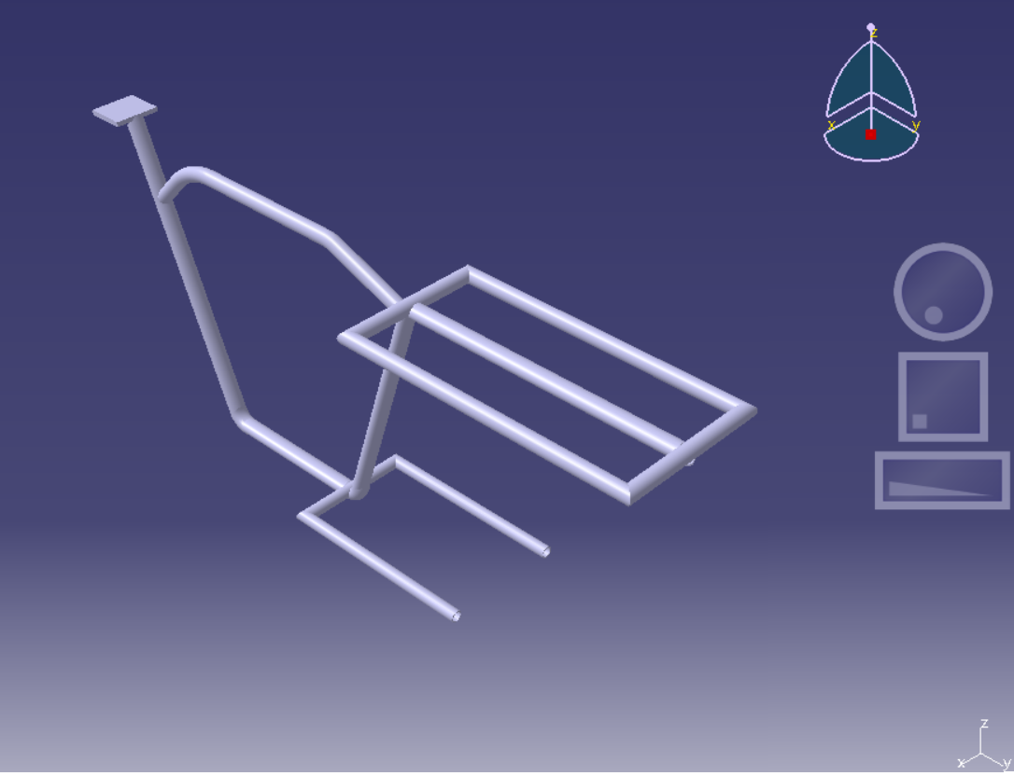

Figure 1 Cad Model

## STRUCTURAL ANALYSIS OF BIKE CHASSIS:

A general-purpose commercial finite element code, Hyper-Mesh and ANSYS is applied to conduct the static simulations. A full 3-D solid model is constructed for the static test simulation. Mixed type of elements which contain quadrilateral as well as triangular elements, have been used in analysis. These 2D elements are converted into 3D tetra elements. The sensitive regions have been re-meshed manually considering the shape and size of the parts. From the analysis the maximum principle stress and total deformation were determined and are shown. Table 13 shows the Material properties of steel.



### LOADING CONDITIONS

The portion of the handle in front is made fixed (as shown in figure 2 by blue color) and then various loads are applied as shown in figure 2 and the analysis was done.

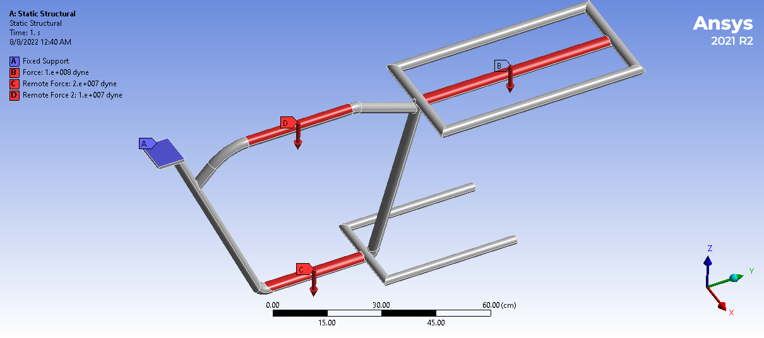

Figure 2 Loading Conditions

### Static Structural

|  |  |  |  |  |
| --- | --- | --- | --- | --- |
| Object Name | Fixed Support | Force | Remote Force | Remote Force 2 |
| State | Fully Defined | | | |
| **Scope** | | | | |
| Scoping Method | Geometry Selection | | | |
| Geometry | 1 Face | | | |
| Object Name | Fixed Support | Force | Remote Force | Remote Force 2 |
| State | Fully Defined | | | |
| **Scope** | | | | |
| Coordinate System |  | | Global Coordinate System | |
| X Coordinate |  | | 1.1833e-008 cm | 8.1942e-017 cm |
| Y Coordinate |  | | 16.742 cm | 10.583 cm |
| Z Coordinate |  | | 0.353 cm | 56.008 cm |
| Location |  | | Defined | |
| **Definition** | | | | |
| Type | Fixed Support | Force | Remote Force | |
| Suppressed | No | | | |
| Define By |  | Components | | |
| Applied By |  | Surface Effect |  | |
| Coordinate System |  | Global Coordinate System |  | |
| X Component |  | 0. dyne (ramped) | | |
| Y Component |  | 0. dyne (ramped) | | |
| Z Component |  | -1.e+008 dyne (ramped) | -2.e+007 dyne (ramped) | -1.e+007 dyne (ramped) |
| Behavior |  | | Deformable | |
| **Advanced** | | | | |
| Pinball Region |  | | All | |

Table 1Loads

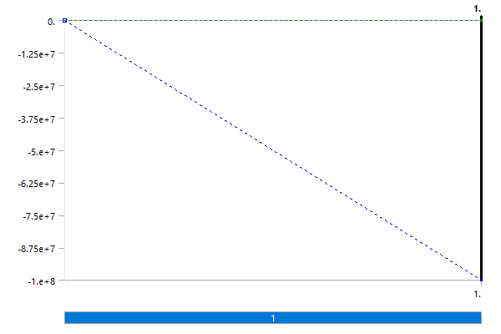

Figure 3Force

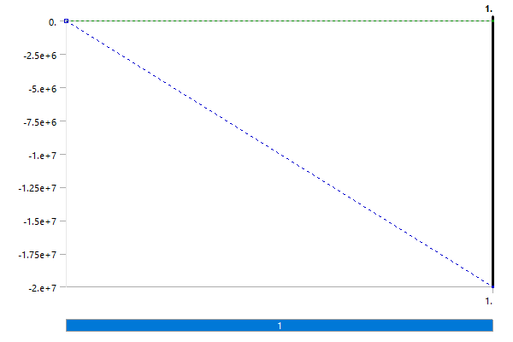

Figure 4Remote Force

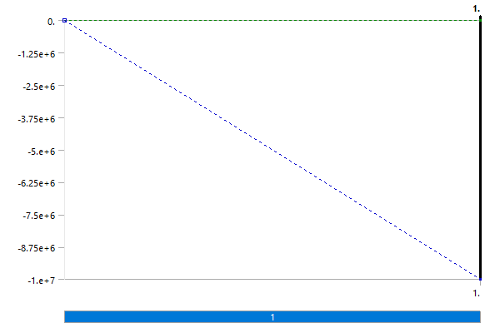

Figure 5Remote Force 2

## Results

|  |  |  |  |  |  |  |
| --- | --- | --- | --- | --- | --- | --- |
| Object Name | Total Deformation | Maximum Principal Stress | Maximum Shear Stress | Equivalent Stress | Strain Energy | Equivalent Elastic Strain |
| State | Solved | | | | | |
| **Scope** | | | | | | |
| Scoping Method | Geometry Selection | | | | | |
| Geometry | All Bodies | | | | | |
| **Definition** | | | | | | |
| Type | Total Deformation | Maximum Principal Stress | Maximum Shear Stress | Equivalent (von-Mises) Stress | Strain Energy | Equivalent Elastic Strain |
| By | Time | | | | | |
| Display Time | Last | | | | | |
| Calculate Time History | Yes | | | | | |
| Suppressed | No | | | | | |
| **Results** | | | | | | |
| Minimum | 0. cm | -1.1294e+010 dyne/cm² | 0.16492 dyne/cm² | 0.29296 dyne/cm² | 3.8603e-015 erg | 6.9901e-013 cm/cm |
| Maximum | 27.935 cm | 5.8874e+010 dyne/cm² | 2.7718e+010 dyne/cm² | 5.103e+010 dyne/cm² | 3.9272e+007 erg | 3.0693e-002 cm/cm |
| Average | 15.81 cm | 3.491e+008 dyne/cm² | 3.4117e+008 dyne/cm² | 6.4549e+008 dyne/cm² |  | 3.6262e-004 cm/cm |
| Minimum Occurs On | chasis-FreeParts|Brep With Voids | | | | | |
| Maximum Occurs On | chasis-FreeParts|Brep With Voids | | | | | |
| Total |  | | | | 1.1803e+009 erg |  |

Table 2Geometry



### Mesh

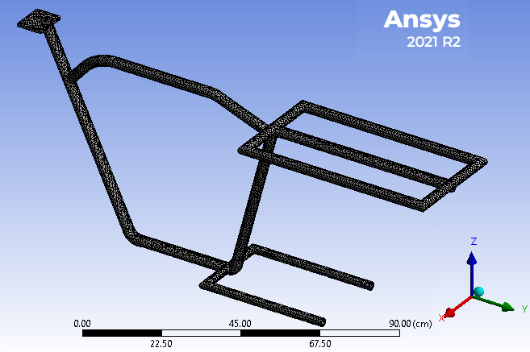

Figure 6Mesh

|  |  |
| --- | --- |
| **Definition** | |
| Suppressed | No |
| Stiffness Behavior | Flexible |
| Coordinate System | Default Coordinate System |
| Reference Temperature | By Environment |
| Treatment | None |
| **Material** | |
| Assignment | Structural Steel |
| Nonlinear Effects | Yes |
| Thermal Strain Effects | Yes |
| **Properties** | |
| Volume | 1218. cm³ |
| Mass | 9561.2 g |
| Centroid X | -3.2211e-004 cm |
| Centroid Y | 41.807 cm |
| Centroid Z | 36.673 cm |
| Moment of Inertia Ip1 | 2.0685e+007 g·cm² |
| Moment of Inertia Ip2 | 5.3207e+006 g·cm² |
| Moment of Inertia Ip3 | 1.6834e+007 g·cm² |
| **Statistics** | |
| Nodes | 78812 |
| Elements | 39598 |

Table 3Geometry

### Total Deformation

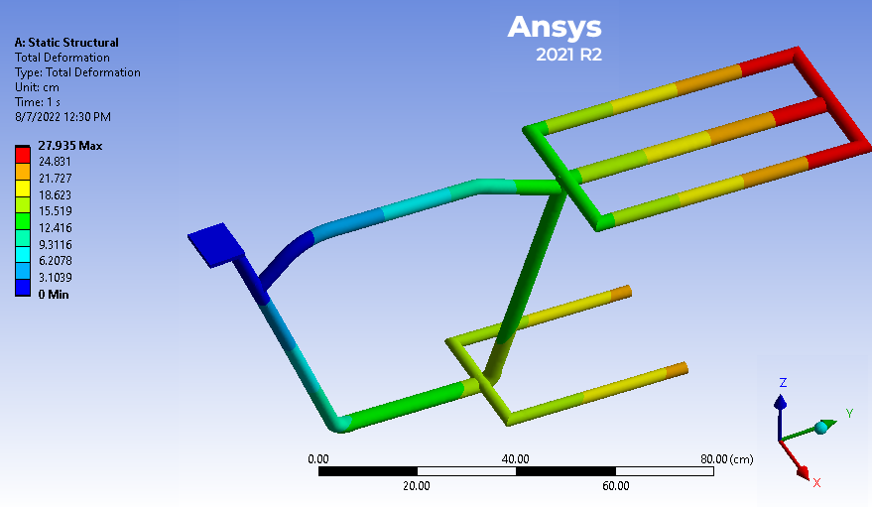

Figure 7Total Deformation

|  |  |  |  |
| --- | --- | --- | --- |
| Time [s] | Minimum [cm] | Maximum [cm] | Average [cm] |
| 1. | 0. | 27.935 | 15.81 |

Table 4Total Deformation

### Maximum Principal Stress

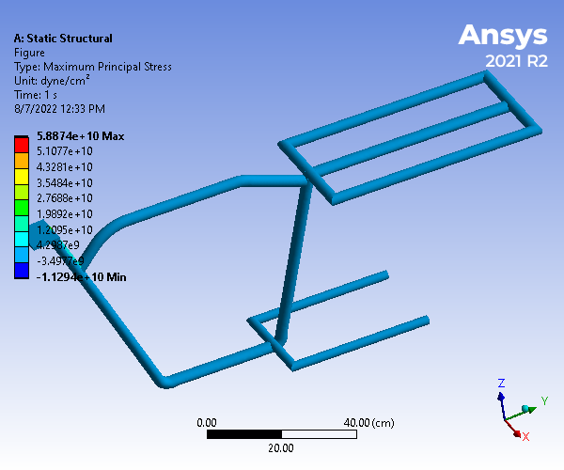

Figure 8Maximum Principal Stress

|  |  |  |  |
| --- | --- | --- | --- |
| Time [s] | Minimum [dyne/cm²] | Maximum [dyne/cm²] | Average [dyne/cm²] |
| 1. | -1.1294e+010 | 5.8874e+010 | 3.491e+008 |

Table 5Maximum Principal Stress

### Maximum Shear Stress

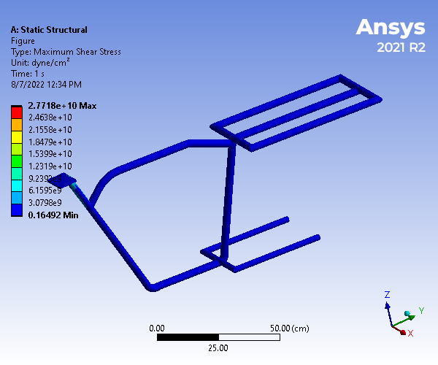

Figure 9Maximum Shear Stress

|  |  |  |  |
| --- | --- | --- | --- |
| Time [s] | Minimum [dyne/cm²] | Maximum [dyne/cm²] | Average [dyne/cm²] |
| 1. | 0.16492 | 2.7718e+010 | 3.4117e+008 |

Table 6Maximum Shear Stress

### Equivalent Stress

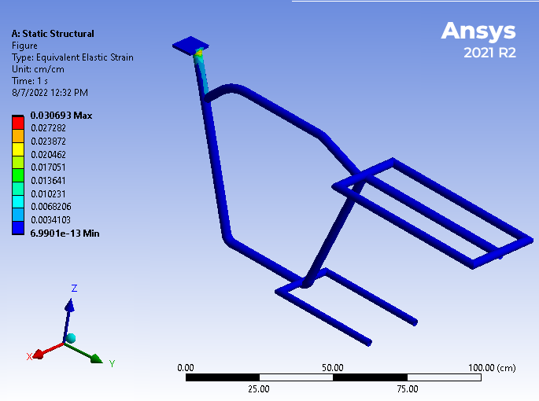

Figure 10Equivalent Stress

|  |  |  |  |
| --- | --- | --- | --- |
| Time [s] | Minimum [dyne/cm²] | Maximum [dyne/cm²] | Average [dyne/cm²] |
| 1. | 0.29296 | 5.103e+010 | 6.4549e+008 |

Table 7Equivalent Stress

### Strain Energy

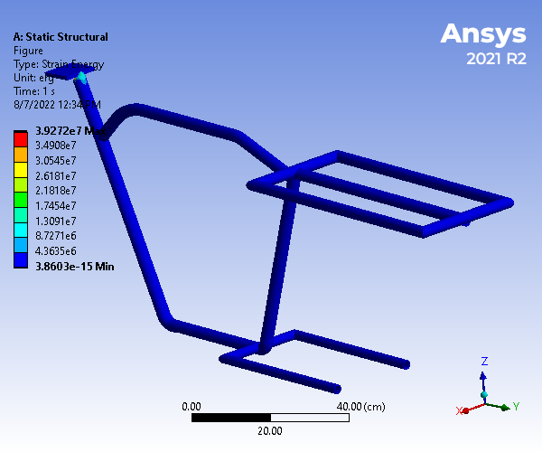

Figure 11Strain

|  |  |  |  |
| --- | --- | --- | --- |
| Time [s] | Minimum [erg] | Maximum [erg] | Total [erg] |
| 1. | 3.8603e-015 | 3.9272e+007 | 1.1803e+009 |

Table 8Strain Energy

### Equivalent Elastic Strain

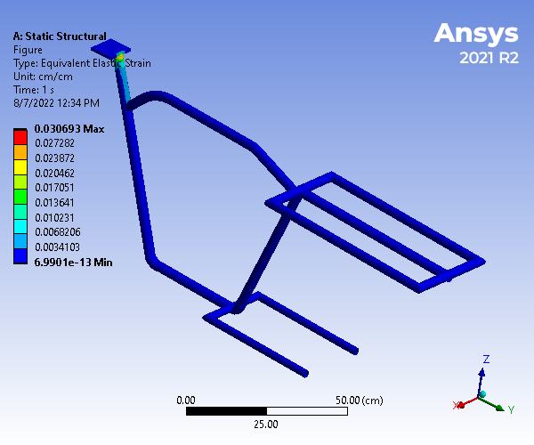

Figure 12Equivalent Elastic Strain

|  |  |  |  |
| --- | --- | --- | --- |
| Time [s] | Minimum [cm/cm] | Maximum [cm/cm] | Average [cm/cm] |
| 1. | 6.9901e-013 | 3.0693e-002 | 3.6262e-004 |

Table 9Equivalent Elastic Strain

### Safety Factor

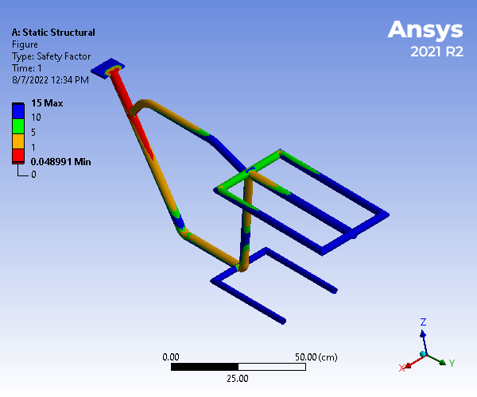

Figure 13Safety Factor

|  |  |  |  |
| --- | --- | --- | --- |
| Time [s] | Minimum | Maximum | Average |
| 1. | 4.8991e-002 | 15. | 10.054 |

Table 10Safety Factor

|  |  |
| --- | --- |
| Object Name | Stress Tool |
| State | Solved |
| **Definition** | |
| Theory | Max Equivalent Stress |
| Stress Limit Type | Tensile Yield Per Material |

Table 11 Safety Tools

|  |  |
| --- | --- |
| Object Name | Safety Factor |
| State | Solved |
| **Scope** | |
| Scoping Method | Geometry Selection |
| Geometry | All Bodies |
| **Definition** | |
| Type | Safety Factor |
| By | Time |
| Display Time | Last |
| Calculate Time History | Yes |
| Identifier |  |
| Suppressed | No |
| **Integration Point Results** | |
| Display Option | Averaged |
| Average Across Bodies | No |
| **Results** | |
| Minimum | 4.8991e-002 |
| Minimum Occurs On | chasis-FreeParts|Brep With Voids |
| **Information** | |
| Time | 1. s |
| Load Step | 1 |
| Substep | 1 |
| Iteration Number | 1 |

Table 12 Stress Tool

### Harmonic Response

Harmonic Response of the chassis was done by fixing handle portion as same in other analysis and load was just applied in the seat considering the force due to the applied load and the result is found to be as below.

|  |  |
| --- | --- |
| Object Name | Force |
| State | Fully Defined |
| **Scope** | |
| Scoping Method | Geometry Selection |
| Geometry | 1 Face |
| **Definition** | |
| Type | Force |
| Define By | Components |
| Applied By | Surface Effect |
| Coordinate System | Global Coordinate System |
| X Component | 0. N |
| Y Component | 0. N |
| Z Component | -800. N |
| X Phase Angle | 0. ° |
| Y Phase Angle | 0. ° |
| Z Phase Angle | 0. ° |
| Suppressed | No |

Table 13Harmonic Response on Loads at seat

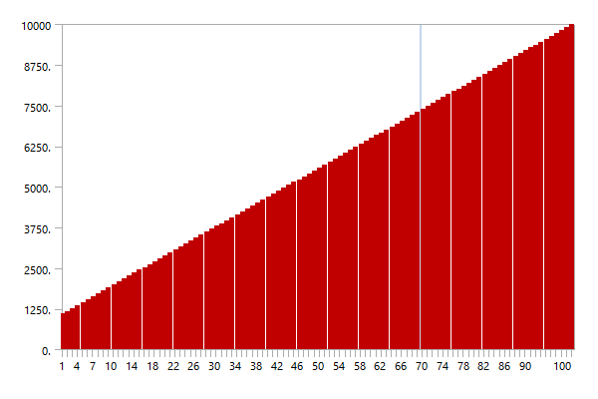

Figure 14 Harmonic Response Solution

|  |  |  |
| --- | --- | --- |
| Object Name | Total Deformation | Maximum Principal Elastic Strain |
| State | Solved | |
| **Scope** | | |
| Scoping Method | Geometry Selection | |
| Geometry | All Bodies | |
| **Definition** | | |
| Type | Total Deformation | Maximum Principal Elastic Strain |
| By | Frequency | |
| Frequency | Last | |
| Amplitude | No | |
| Sweeping Phase | 0. ° | |
| Identifier |  | |
| Suppressed | No | |
| **Results** | | |
| Minimum | 2.8095e-011 m | -8.1773e-008 m/m |
| Maximum | 6.194e-007 m | 6.7067e-006 m/m |
| Average | 3.5218e-008 m | 1.9526e-007 m/m |
| Minimum Occurs On | chasis-FreeParts|Brep With Voids | |
| Maximum Occurs On | chasis-FreeParts|Brep With Voids | |
| **Information** | | |
| Reported Frequency | 10000 Hz | |
| **Integration Point Results** | | |
| Display Option |  | Averaged |
| Average Across Bodies |  | No |

Table 14**Harmonic Response Solution Results**

## Material Data

**Structural Steel**

|  |  |
| --- | --- |
| Density | 7.85 g cm^-3 |
| Coefficient of Thermal Expansion | 1.2e-005 C^-1 |
| Specific Heat | 4.34e+006 erg g^-1 C^-1 |
| Thermal Conductivity | 0.605 W cm^-1 C^-1 |
| Resistivity | 1.7e-005 ohm cm |

Table 15 Structural Steel Constants

|  |  |  |
| --- | --- | --- |
| Red | Green | Blue |
| 132 | 139 | 179 |

Table 16Structural Steel Color

|  |
| --- |
| Compressive Ultimate Strength dyne cm^-2 |
| 0 |

Table 17Structural Steel Compressive Ultimate Strength

|  |
| --- |
| Compressive Yield Strength dyne cm^-2 |
| 2.5e+009 |

Table 18Structural Steel Compressive Yield Strength

|  |
| --- |
| Tensile Yield Strength dyne cm^-2 |
| 2.5e+009 |

Table 19Structural Steel Tensile Yield Strength

|  |
| --- |
| Tensile Ultimate Strength dyne cm^-2 |
| 4.6e+009 |

Table 20Structural Steel Tensile Ultimate Strength

|  |
| --- |
| Zero-Thermal-Strain Reference Temperature C |
| 22 |

Table 21 Structural Steel Isotropic Secant Coefficient of Thermal Expansion

|  |  |  |
| --- | --- | --- |
| Alternating Stress dyne cm^-2 | Cycles | Mean Stress dyne cm^-2 |
| 3.999e+010 | 10 | 0 |
| 2.827e+010 | 20 | 0 |
| 1.896e+010 | 50 | 0 |
| 1.413e+010 | 100 | 0 |
| 1.069e+010 | 200 | 0 |
| 4.41e+009 | 2000 | 0 |
| 2.62e+009 | 10000 | 0 |
| 2.14e+009 | 20000 | 0 |
| 1.38e+009 | 1.e+005 | 0 |
| 1.14e+009 | 2.e+005 | 0 |
| 8.62e+008 | 1.e+006 | 0 |

Table 22Structural Steel S-N Curve

|  |  |  |  |  |  |
| --- | --- | --- | --- | --- | --- |
| Strength Coefficient dyne cm^-2 | Strength Exponent | Ductility Coefficient | Ductility Exponent | Cyclic Strength Coefficient dyne cm^-2 | Cyclic Strain Hardening Exponent |
| 9.2e+009 | -0.106 | 0.213 | -0.47 | 1.e+010 | 0.2 |

Table 23Structural Steel Strain-Life Parameters

|  |  |  |  |  |
| --- | --- | --- | --- | --- |
| Young's Modulus dyne cm^-2 | Poisson's Ratio | Bulk Modulus dyne cm^-2 | Shear Modulus dyne cm^-2 | Temperature C |
| 2.e+012 | 0.3 | 1.6667e+012 | 7.6923e+011 |  |

Table 24Structural Steel Isotropic Elasticity

|  |
| --- |
| Relative Permeability |
| 10000 |

Table 25Structural Steel Isotropic Relative Permeability

## CONCLUSION:

Hence structural analysis of the Stainless steel has be done by using stainless steel using ANSYS software. From the result it is observed that the stresses are maximum at the joint location and also for all the materials the stress value values are less that their permissible yields stress values. So the design is safe. Stainless steel materials is also cheap in cost, so this is the best suitable material for chassis frame and is expected to perform better with satisfying amount of weight reduction